**Objectives:**

1. To connect Java to MySQL server
2. Create Encapsulated class for CRUD operations and other transactions

**Materials:**

1. PC or Laptop
2. WAMP/XAMPP Installer
3. Web Browser or CLI

**Background**

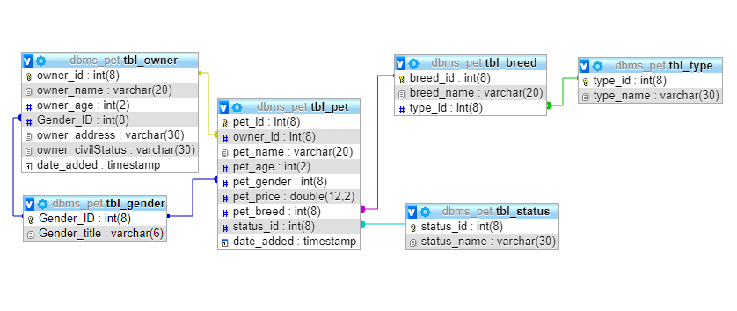

**Instructions:**

1. **Create java project “Pet Management System”. Then, drag all the files [Downloaded java file], including all classes, to your project.**

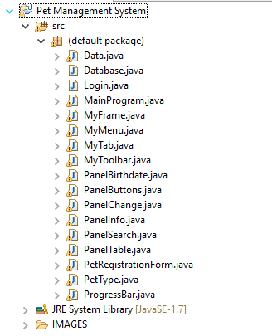

1. **Right-click on the project. Then, click Build path>Add External Achieves**

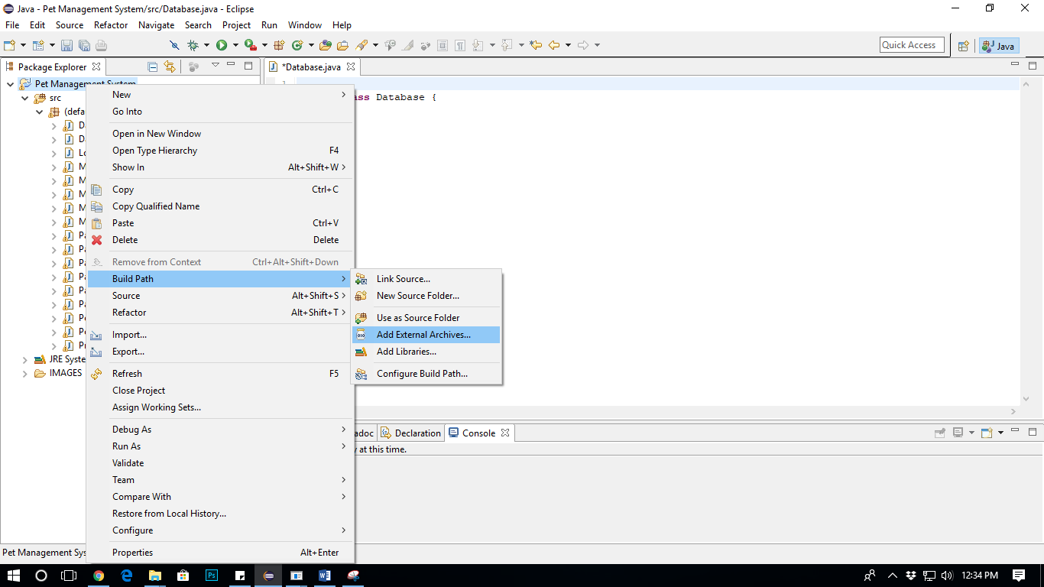

1. **Then follow the display below:**

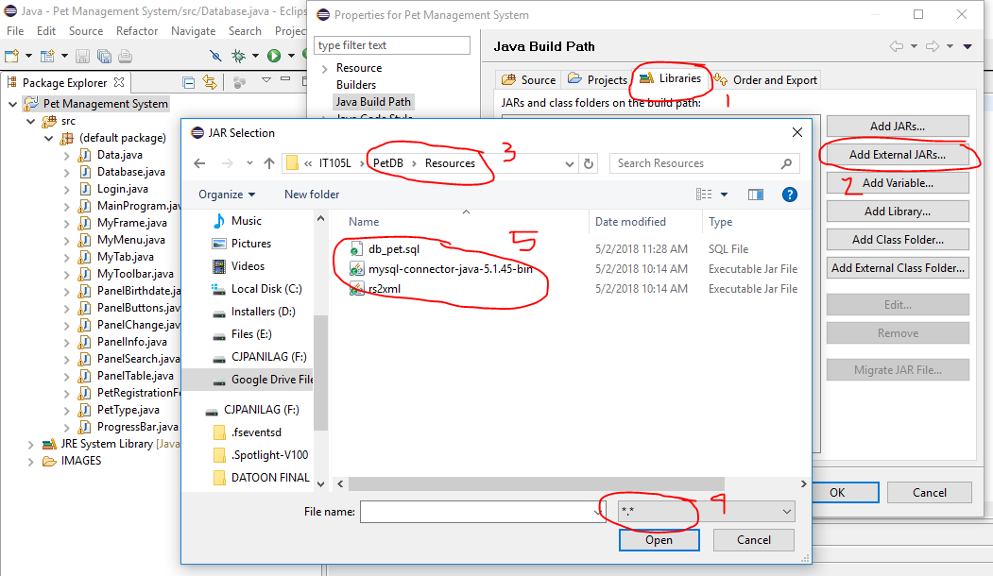

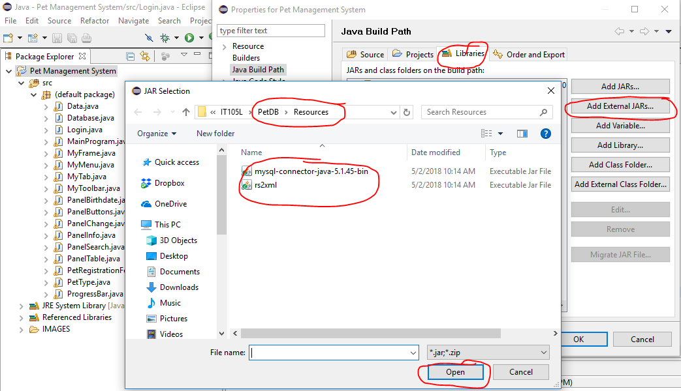

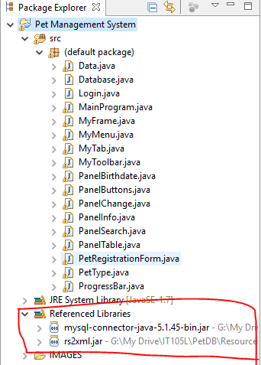

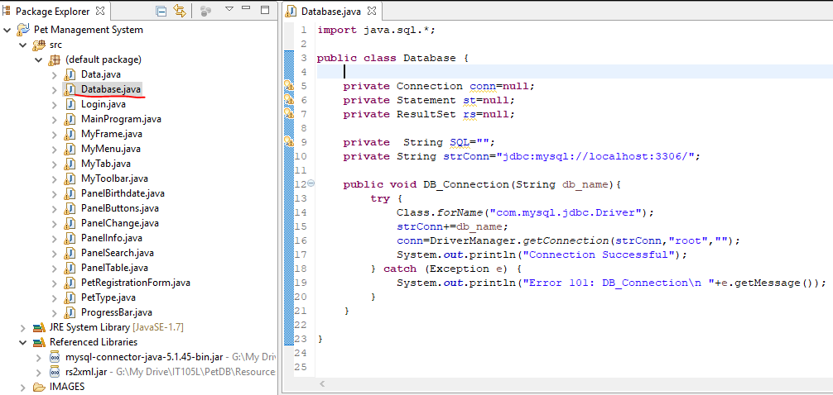

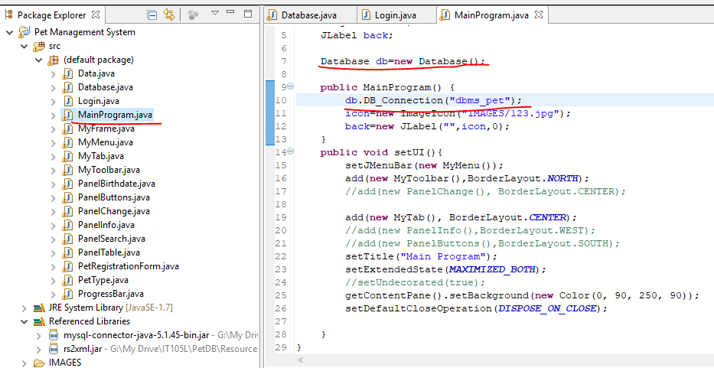

**Run the program**

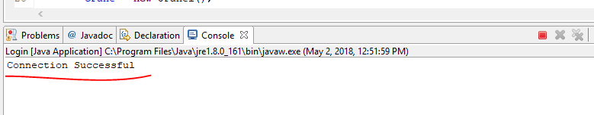

**Error**

